#Upload files from one S3 bucket to another S3 with help of AWS CLI.

* To create S3 bucket with help of CLI, I ran below command  
    
  **aws s3api create-bucket --bucket mysourcebuck --region ap-south-1**



* Above command will give error since we have used region as ap-south-1, instead we should use us-east-1 for bucket creation.
* We should use LocationConstraint=ap-south-1 attribute while creating bucket other than **us-east-1** region
* Using below command I have created the **bucket as source**.  
  **aws s3api create-bucket --bucket macmysourcebuck --region ap-south-1 --create-bucket-configuration LocationConstraint=ap-south-1**
* Likewise we can **create destination bucket**,  
  **aws s3api create-bucket --bucket macmydestinationbuck --region ap-south-1 --create-bucket-configuration LocationConstraint=ap-south-1**
* We can see source and destination bucket in console  
    
  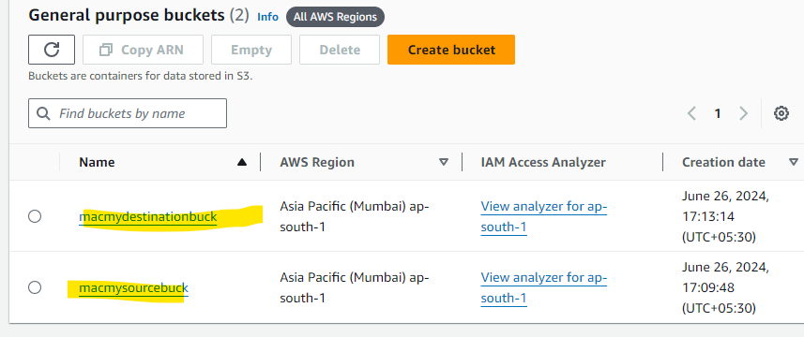
* Below command will be used to cp the file from source to the destination server.

**aws s3 cp s3://macmysourcebuck/TestFile1.txt s3://macmydestinationbuck/**

* We can list all S3 bucket objects with help of below command  
  **aws s3 ls macmydestinationbuck**

===========================================================================

We can enable versioning on bucket with below command

**aws s3api put-bucket-versioning --bucket my-comprehensive-bucket --versioning-configuration Status=Enabled**

To check the current versioning status of bucket using below command

**aws s3api get-bucket-versioning --bucket macmysourcebuck**

And finally we **can’t completely disable** the versioning instead we will **suspend** (Status=Suspended)